**⇒ Hands-On Exercises**

**Exercise 1: Control Structures**

Scenario 1: The bank wants to apply a discount to loan interest rates for customers above 60 years old.

SET SERVEROUTPUT ON;

DECLARE

CURSOR cust_cursor IS

SELECT c.CustomerID, c.DOB, l.LoanID, l.InterestRate

FROM Customers c

JOIN Loans l ON c.CustomerID = l.CustomerID;

v_CustomerID Customers.CustomerID%TYPE;

v_DOB Customers.DOB%TYPE;

v_LoanID Loans.LoanID%TYPE;

v_InterestRate Loans.InterestRate%TYPE;

v_Age NUMBER;

BEGIN

FOR rec IN cust_cursor LOOP

v_CustomerID := rec.CustomerID;

v_DOB := rec.DOB;

v_LoanID := rec.LoanID;

v_InterestRate := rec.InterestRate;

v_Age := FLOOR(MONTHS_BETWEEN(SYSDATE, v_DOB) / 12);

IF v_Age > 60 THEN

UPDATE Loans

SET InterestRate = InterestRate - 1

WHERE LoanID = v_LoanID;

DBMS_OUTPUT.PUT_LINE('Discount applied for Customer ID: ' || v_CustomerID || ' | Age: ' || v_Age);

ELSE

DBMS_OUTPUT.PUT_LINE('No discount for Customer ID: ' || v_CustomerID || ' | Age: ' || v_Age);

END IF;

END LOOP;

COMMIT;

END;

/

SELECT LoanID, CustomerID, InterestRate FROM Loans;

Result:

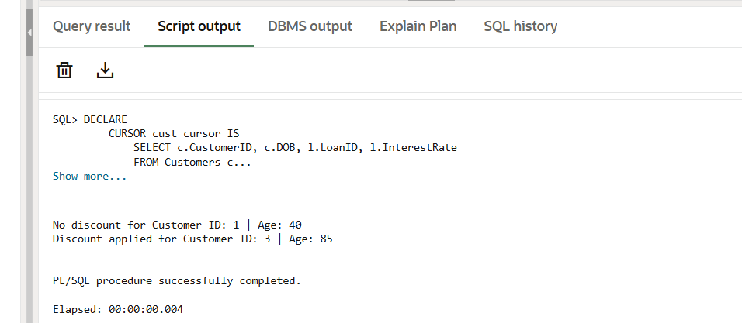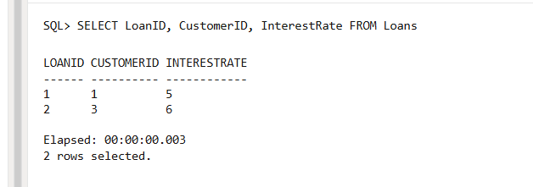

Scenario 2: A customer can be promoted to VIP status based on their balance.

ALTER TABLE Customers ADD IsVIP VARCHAR2(5);

UPDATE Customers SET IsVIP = 'FALSE';

COMMIT;

SET SERVEROUTPUT ON;

DECLARE

CURSOR vip_cursor IS

SELECT CustomerID, Balance FROM Customers;

v_CustomerID Customers.CustomerID%TYPE;

v_Balance Customers.Balance%TYPE;

BEGIN

FOR rec IN vip_cursor LOOP

v_CustomerID := rec.CustomerID;

v_Balance := rec.Balance;

IF v_Balance > 10000 THEN

UPDATE Customers

SET IsVIP = 'TRUE'

WHERE CustomerID = v_CustomerID;

DBMS_OUTPUT.PUT_LINE('Marked VIP: Customer ID = ' || v_CustomerID || ' | Balance = ' || v_Balance);

ELSE

DBMS_OUTPUT.PUT_LINE('Not VIP: Customer ID = ' || v_CustomerID || ' | Balance = ' || v_Balance);

END IF;

END LOOP;

COMMIT;

END;

/

SELECT CustomerID, Name, Balance, IsVIP FROM Customers;

Result:

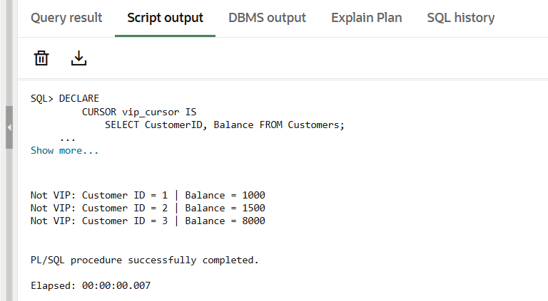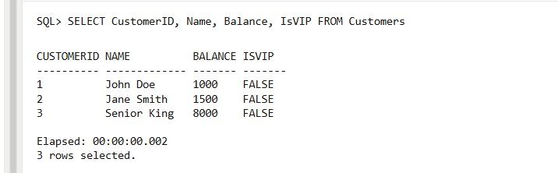

Scenario 3: The bank wants to send reminders to customers whose loans are due within the next 30 days.

SET SERVEROUTPUT ON;

DECLARE

CURSOR loan_cursor IS

SELECT CustomerID, EndDate

FROM Loans;

v_CustomerID Loans.CustomerID%TYPE;

v_EndDate Loans.EndDate%TYPE;

BEGIN

FOR rec IN loan_cursor LOOP

v_CustomerID := rec.CustomerID;

v_EndDate := rec.EndDate;

IF v_EndDate <= SYSDATE + 30 THEN

DBMS_OUTPUT.PUT_LINE('Reminder: Customer ID ' || v_CustomerID || ' has a loan due on ' || TO_CHAR(v_EndDate, 'YYYY-MM-DD'));

ELSE

DBMS_OUTPUT.PUT_LINE('No reminder: Customer ID ' || v_CustomerID || ' | Due on ' || TO_CHAR(v_EndDate, 'YYYY-MM-DD'));

END IF;

END LOOP;

END;

/

SELECT LoanID, CustomerID, EndDate FROM Loans;

Result:

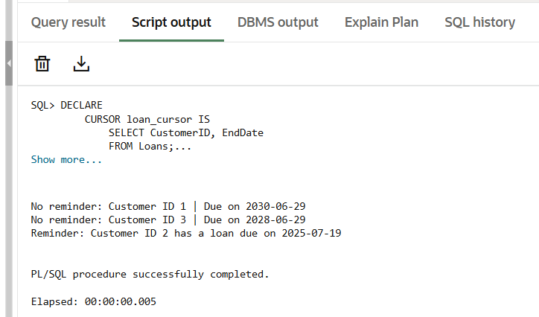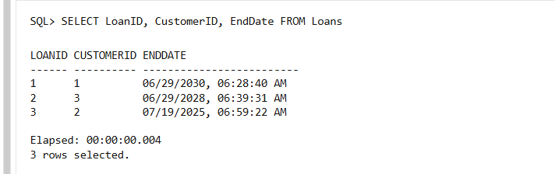

**Exercise 3: Stored Procedures**

Scenario 1: The bank needs to process monthly interest for all savings accounts.

CREATE OR REPLACE PROCEDURE ProcessMonthlyInterest AS

BEGIN

FOR acc IN (

SELECT AccountID, Balance

FROM Accounts

WHERE AccountType = 'Savings'

) LOOP

UPDATE Accounts

SET Balance = Balance + (Balance * 0.01)

WHERE AccountID = acc.AccountID;

DBMS_OUTPUT.PUT_LINE('Interest applied to Account ID: ' || acc.AccountID);

END LOOP;

COMMIT;

END;

/

SET SERVEROUTPUT ON;

BEGIN

ProcessMonthlyInterest;

END;

/

SELECT AccountID, AccountType, Balance FROM Accounts;

Result:

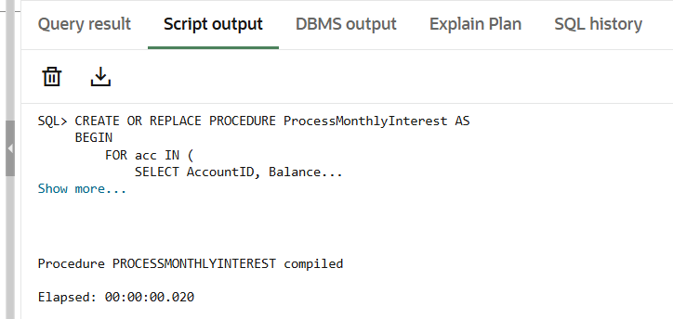

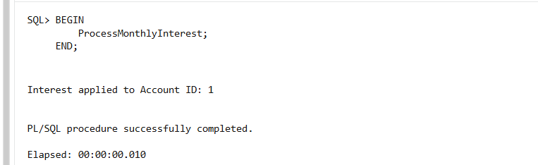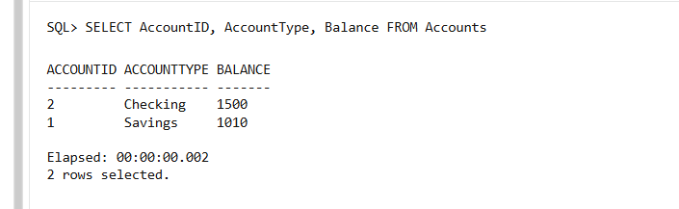

Scenario 2: The bank wants to implement a bonus scheme for employees based on their performance.

CREATE OR REPLACE PROCEDURE UpdateEmployeeBonus (

p_Department IN VARCHAR2,

p_BonusPercent IN NUMBER

) AS

BEGIN

FOR emp IN (

SELECT EmployeeID, Salary

FROM Employees

WHERE Department = p_Department

) LOOP

UPDATE Employees

SET Salary = Salary + (Salary * (p_BonusPercent / 100))

WHERE EmployeeID = emp.EmployeeID;

DBMS_OUTPUT.PUT_LINE('Bonus applied to Employee ID: ' || emp.EmployeeID);

END LOOP;

COMMIT;

END;

/

SET SERVEROUTPUT ON;

BEGIN

UpdateEmployeeBonus('IT', 10);

END;

/

SELECT EmployeeID, Name, Department, Salary FROM Employees;

Result:

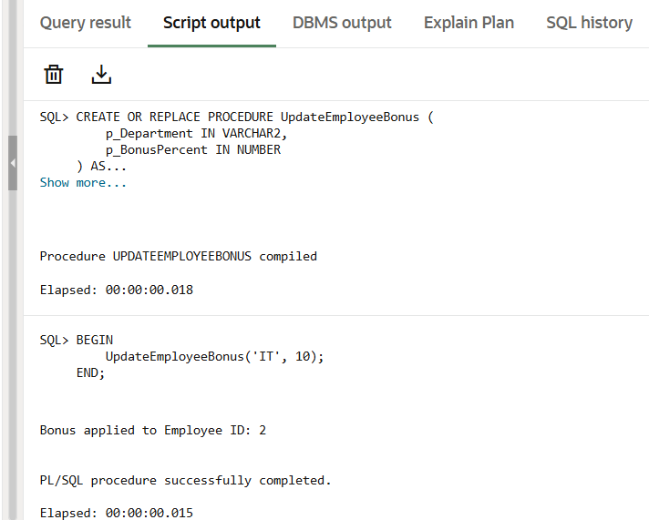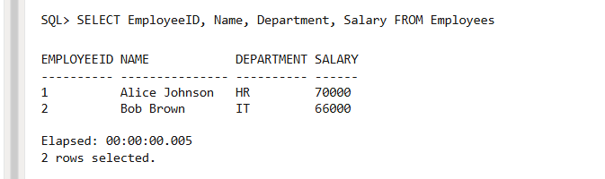

Scenario 3: Customers should be able to transfer funds between their accounts

CREATE OR REPLACE PROCEDURE TransferFunds (

p_FromAccountID IN NUMBER,

p_ToAccountID IN NUMBER,

p_Amount IN NUMBER

) AS

v_FromBalance NUMBER;

BEGIN

SELECT Balance INTO v_FromBalance

FROM Accounts

WHERE AccountID = p_FromAccountID;

IF v_FromBalance >= p_Amount THEN

UPDATE Accounts

SET Balance = Balance - p_Amount

WHERE AccountID = p_FromAccountID;

UPDATE Accounts

SET Balance = Balance + p_Amount

WHERE AccountID = p_ToAccountID;

DBMS_OUTPUT.PUT_LINE('Transferred ' || p_Amount || ' from Account ' || p_FromAccountID || ' to Account ' || p_ToAccountID);

COMMIT;

ELSE

DBMS_OUTPUT.PUT_LINE('Insufficient balance in Account ' || p_FromAccountID);

END IF;

EXCEPTION

WHEN NO_DATA_FOUND THEN

DBMS_OUTPUT.PUT_LINE('One of the accounts does not exist.');

WHEN OTHERS THEN

DBMS_OUTPUT.PUT_LINE('Unexpected error: ' || SQLERRM);

END;

/

SET SERVEROUTPUT ON;

BEGIN

TransferFunds(2, 1, 200);

END;

/

SELECT AccountID, Balance FROM Accounts;

Result:

